

**CLOTHING SHOP PROJECT REPORT**

**Software Design Document**

– Hanoi, Summer 2022 –

**Table of Contents**

I. Overview 6

1. Code Packages/Namespaces 6

2. Coding Conventions 7

II. Code Designs 7

1. <Feature/Function Name1> 8

2. Login 8

a. Class Diagram 8

b. Class Specifications 8

c. Sequence Diagram(s) 9

d. Database queries 9

4. Product detail 10

a. Class Diagram 10

b. Class Specifications 10

c. Sequence Diagram(s) 10

d. Database queries 11

5. Register 11

a. Class Diagram 11

b. Class Specifications 12

c. Sequence Diagram(s) 12

d. Database queries 13

6. Add to cart 13

a. Class Diagram 13

b. Class Specifications 13

c. Sequence Diagram(s) 14

d. Database queries 14

7. Blog List 14

a. Class Diagram 14

b. Class Specifications 14

c. Sequence Diagram(s) 15

d. Database queries 16

8. Blog Detail 16

a. Class Diagram 16

b. Class Specifications 16

c. Sequence Diagram(s) 17

d. Database queries 17

9. Logout 17

a. Class Diagram 17

b.Class Specifications 18

c. Sequence Diagram(s) 18

d. Database queries 19

10. Home Page 19

a. Class Diagram 19

b. Class Specifications 19

c. Sequence Diagram(s) 20

11. Change amount 21

a. Class Diagram 21

b. Class Specifications 21

c. Sequence Diagram(s) 22

12. Delete cart 22

a. Class Diagram 22

b. Class Specifications 22

c. Sequence Diagram(s) 23

13. View List User 24

a. Class Diagram 24

b. Class Specifications 24

c. Sequence Diagram(s) 25

d. Database queries 26

14. Edit Information User 26

a. Class Diagram 26

b. Class Specifications 26

c. Sequence Diagram(s) 27

d. Database queries 28

15.Set Role User 28

a. Class Diagram 28

b. Class Specifications 28

c. Sequence Diagram(s) 29

d. Database queries 29

16. Block User 30

a. Class Diagram 30

b. Class Specifications 30

c. Sequence Diagram(s) 30

d. Database queries 31

17. Reset Password 31

a. Class Diagram 31

b. Class Specifications 31

c. Sequence Diagram(s) 32

d. Database queries 33

18. Change Password 33

a. Class Diagram 33

b. Class Specifications 33

c. Sequence Diagram(s) 34

d. Database queries 35

19. User profile 35

a. Class Diagram 35

b. Class Specifications 35

c. Sequence Diagram(s) 36

d. Database queries 37

20. Order History 37

a. Class Diagram 37

b. Class Specifications 37

c. Sequence Diagram(s) 38

d. Database queries

24. Manager Product

1. Class Diagram
2. Class Specifications
3. Sequence Digrams
4. Database queries

III. Database Design 40

1. Database Schema 40

2. Table Description 40

# I. Overview

## 1. Code Packages/Namespaces

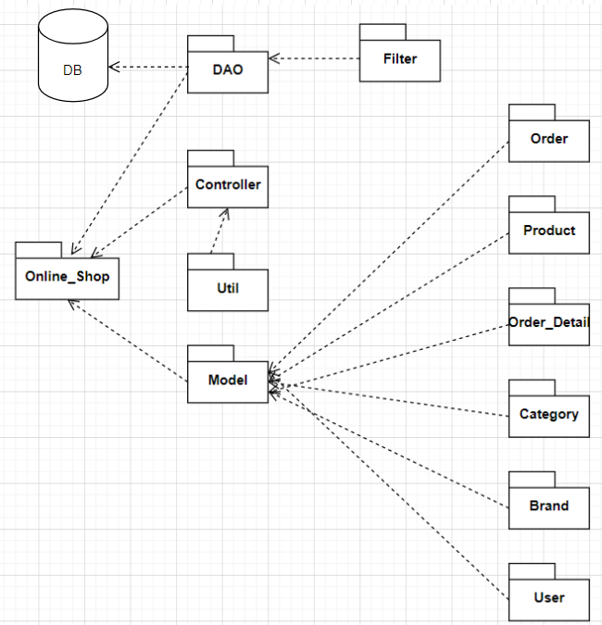

***Package descriptions & package class naming conventions***

| **No** | **Package** | **Description** |
| --- | --- | --- |
| *01* | *Controllers* | This package contains all controllers for this MVC2 project and authentication or dispatcher filters  Servlet Naming convention: Starting with a verb.  Ex: LoginController, SignUpController,... |
| *02* | *Views* | This package contains all views (HTML,CSS,JS,JSP file) for this project  HTML/CSS/JS/JSP file naming convention: first letter is a lowercase letter, using camelCase naming |
| *03* | *Model* | This package provide the connection to the Database, Extract data for the system  Naming convention: first letter is a lowercase letter, the name is using camelCase naming  This package .java files which allow developers to skip writing DAOs for their persistence objects when they usingJDBC. |
| *04* | *Utils* | This package contains DBcontext.java file which is a bridge connection between database and programming and contains sendEmail.java allows users to send email  Naming convention: first letter is a lowercase letter, the name is using camelCase naming |
| *05* | *Filter* | This package handles the Authentication that helps avoid duplicate in controller  Naming convention: first letter is a lowercase letter, the name is using camelCase naming |

## 2. Coding Conventions

# II. Code Designs

## 1. <Feature/Function Name1>

## 2. Login

### Class Diagram

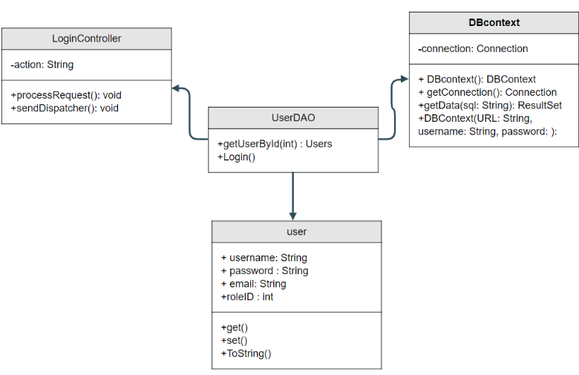

### Class Specifications

UserController

| No | Method | Description |
| --- | --- | --- |
| 01 | processRequest() | get all new information from user Form and update the database |

UserDAO

[Provide the detailed description for the class methods]

| No | Method | Description |
| --- | --- | --- |
| 01 | getUserList() | get the list of user |
| 02 | getUserById(int uId) | get the user where the user id is |

### Sequence Diagram(s)

### Database queries

**"select * from [User] where username=? and password=?"**

**3.Cart Detail**

1. **Class Diagram**

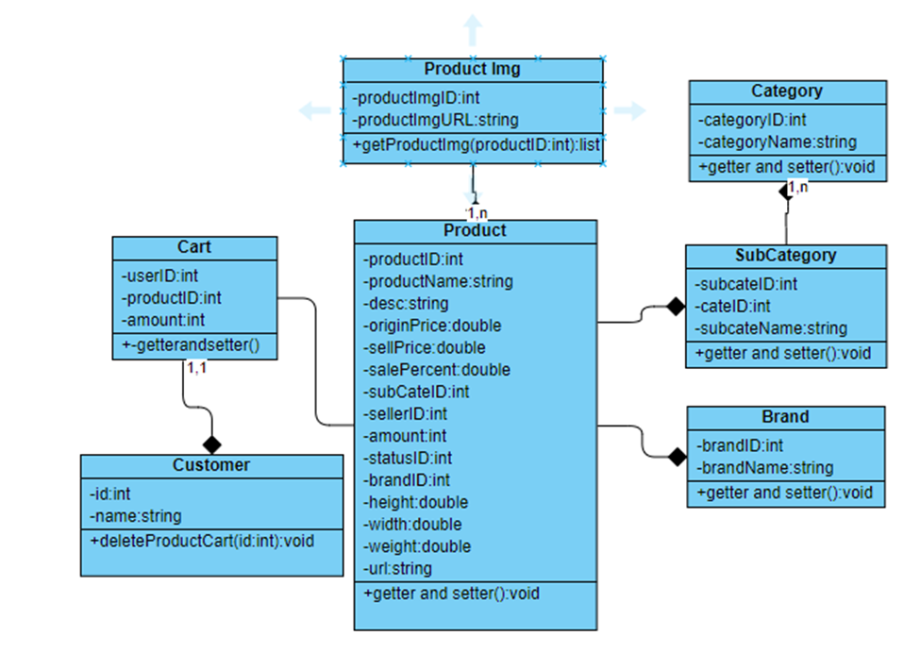

### 

## 4. Product detail

### Class Diagram

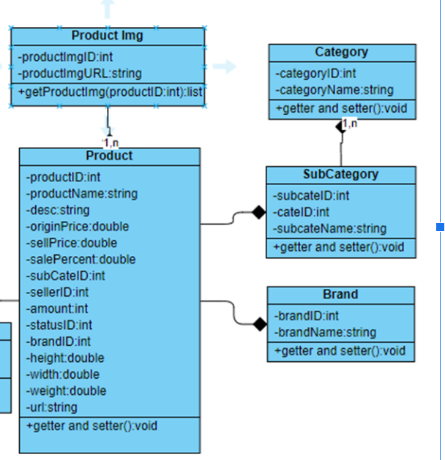

### Class Specifications

| No | Method | Description |
| --- | --- | --- |
| 01 | processRequest() |  |

ProductDAO

| No | Method | Description |
| --- | --- | --- |
| 01 | getProductByID(int id) | get Product by ID |

### 

### c. Sequence Diagram(s)

### 

### d. Database queries

"select p.*,s.SubCategoryName,c.*,b.BrandName from Product p join SubCategory s \n"

+ "on p.SubCategoryID = s.SubCategoryID\n"

+ "join Brand b on b.BrandID = p.BrandID\n"

+ "join Category c on c.CategoryID = s.CategoryID"

## 5. Register

### **a. Class Diagram**

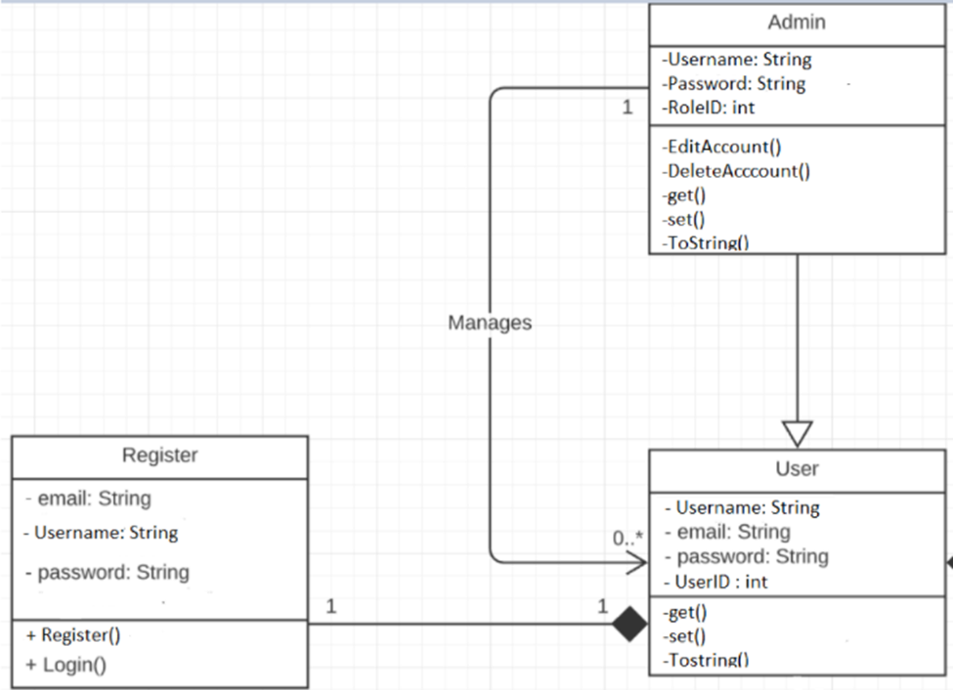

### b. Class Specifications

UserController

| No | Method | Description |
| --- | --- | --- |
| 01 | processRequest() |  |

UserDAO

[Provide the detailed description for the class methods]

| No | Method | Description |
| --- | --- | --- |
| 01 | Register( String username,String password, String mai) | insert a new user with Name , Pass, Mail) |
| 02 | checkExistAccount(String xName) | - check if the username is already exist  - return null |

### 

### c. Sequence Diagram(s)

### 

### d. Database queries

**"**INSERT INTO [dbo].[Users]

([Username

,[Password]

,[email]

,[RoleID]

,[isBlock])

VALUES (?,?,?,?,?)"**"**

## 6. Add to cart

### Class Diagram



### Class Specifications

CartDetailController

| No | Method | Description |
| --- | --- | --- |
| 01 | processRequest() |  |

CartDAO

[Provide the detailed description for the class methods]

| No | Method | Description |
| --- | --- | --- |
| *01* | *deleteProductCart()* | *Remove a product() from cart* |

### 

### c. Sequence Diagram(s)

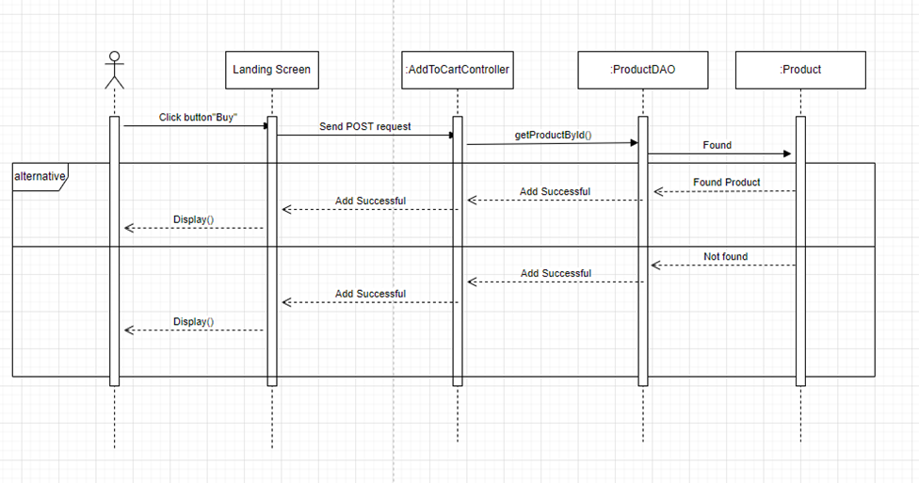

## Blog List

### Class Diagram

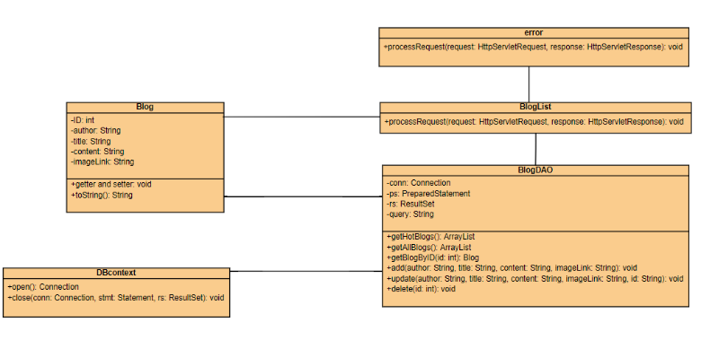

### Class Specifications

- BlogList class

| **No** | **Method** | **Description** |
| --- | --- | --- |
| 01 | processRequest() | get blog list from the database to display on BlogList.jsp |

- BlogDAO class

| **No** | **Method** | **Description** |
| --- | --- | --- |
| 01 | getBlogByID(int id) | Return: Blog Detail where blog id contain parameter  Input: ID of blog |
| 02 | getHotBlogs() | Return: top 3 newest blog from database |
| 03 | getAllBlog() | Return: All blog in database |
| 04 | add(String author, String title, String content, String imageLink) | Add blog with detail entered in addBlog.jsp page  Return: null  Input: author, title, content, imageLink |
| 05 | update(String author, String title, String content, String imageLink, String id) | Update blog with detail entered in updateBlog.jsp page  Return: null  Input: author, title, content, imageLink, id |
| 06 | delete(int id) | Update blog with id entered in blogManage.jsp  Return: null  Input: id |

### 

### c. Sequence Diagram(s)

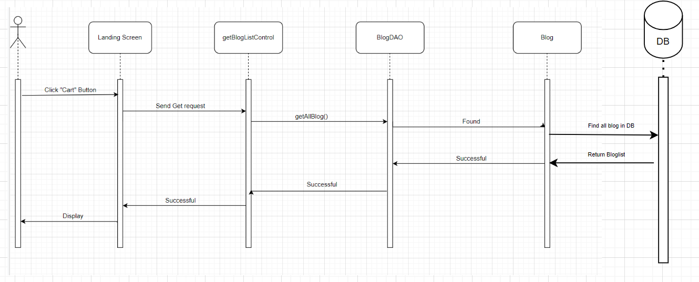

### 

### d. Database queries

**Select * from Blog desc**

## 8. Blog Detail

### Class Diagram

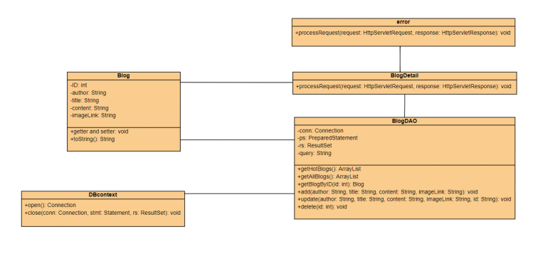

### Class Specifications

- BlogDetail class

| **No** | **Method** | **Description** |
| --- | --- | --- |
| 01 | processRequest() | get blog detail from the database to display on BlogDetail.jsp |

- BlogDAO class

| **No** | **Method** | **Description** |
| --- | --- | --- |
| 01 | getBlogByID(int id) | Return: Blog Detail where blog id contain parameter  Input: ID of blog |
| 02 | getHotBlogs() | Return: top 3 newest blog from database |
| 03 | getAllBlog() | Return: All blog in database |
| 04 | add(String author, String title, String content, String imageLink) | Add blog with detail entered in addBlog.jsp page  Return: null  Input: author, title, content, imageLink |
| 05 | update(String author, String title, String content, String imageLink, String id) | Update blog with detail entered in updateBlog.jsp page  Return: null  Input: author, title, content, imageLink, id |
| 06 | delete(int id) | Update blog with id entered in blogManage.jsp  Return: null  Input: id |

### 

### c. Sequence Diagram(s)

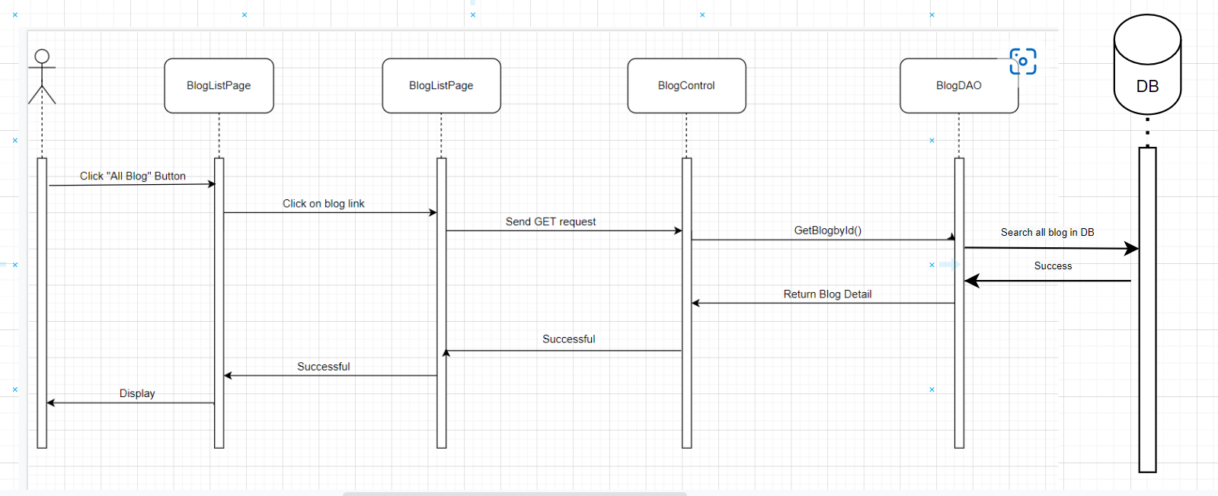

### 

### d. Database queries

SELECT * FROM Blog WHERE ID = ?

## 9. Logout

### a. Class Diagram

### b.Class Specifications

LogoutController

| No | Method | Description |
| --- | --- | --- |
| 01 | processRequest() | Remove attribute from session |

### 

### c. Sequence Diagram(s)

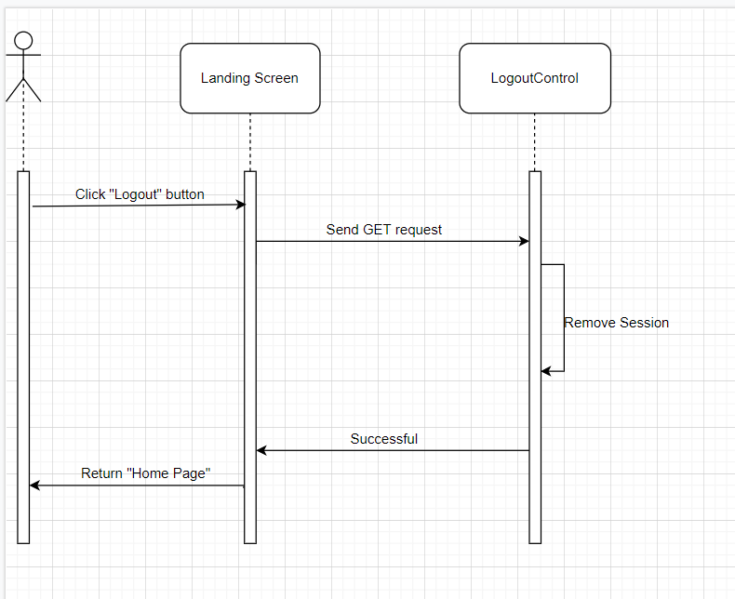

### 

### d. Database queries

## 10. Add Product

### a. Class Diagram

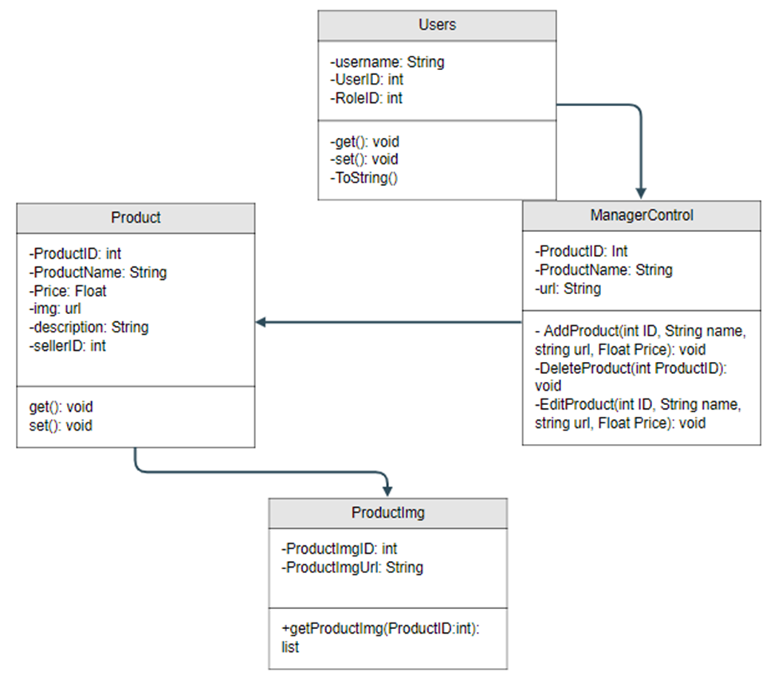

### b. Class Specifications

| No | Method | Description |
| --- | --- | --- |
| 01 | addProduct() | AddProduct from the database to display on ManageProduct.jsp |

### 

### c. Sequence Diagram(s)

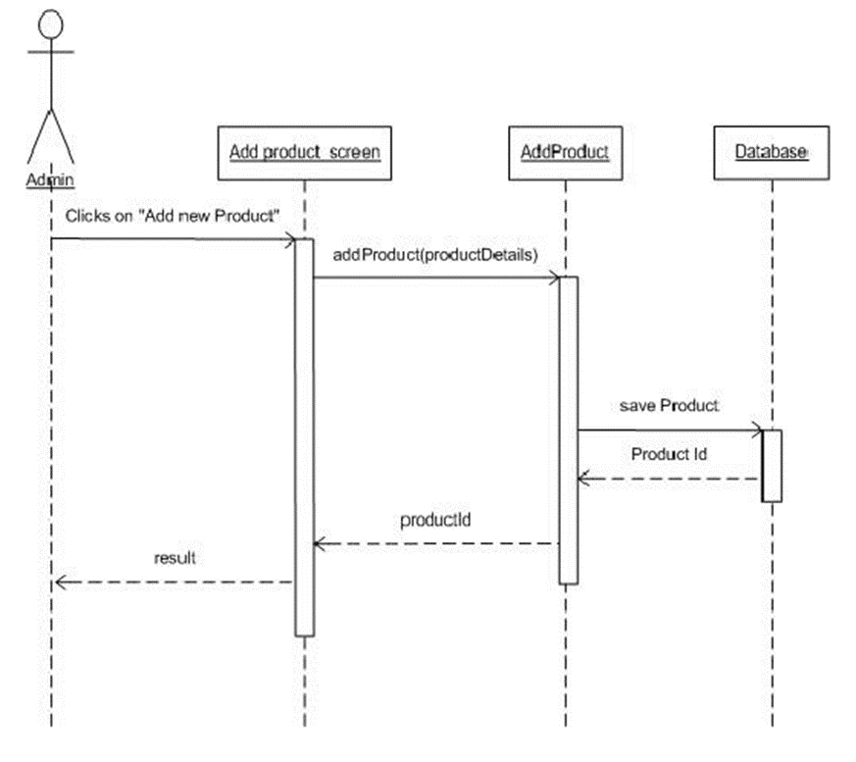

## 

## 11. Change amount

### Class Diagram

### Class Specifications

### 

UserController

| No | Method | Description |
| --- | --- | --- |
| 01 | processRequest() | Update Quantity Cart from Cart Detail |

### 

### c. Sequence Diagram(s)

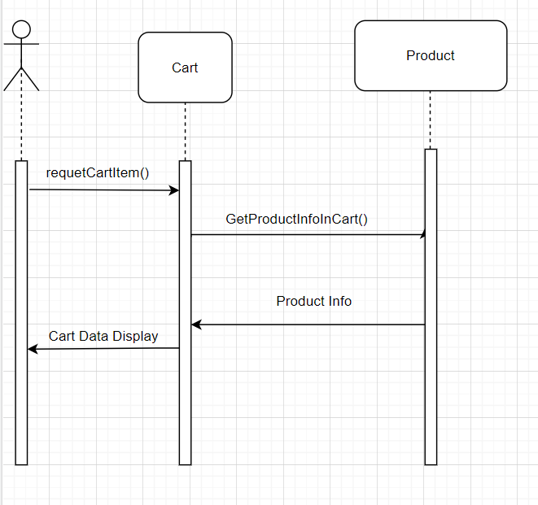

### 

## 12. Delete cart

### a. Class Diagram

### b. Class Specifications

UserController

| No | Method | Description |
| --- | --- | --- |
| 01 | processRequest() | Delete Cart by ProductID through HashMap |

### 

### c. Sequence Diagram(s)

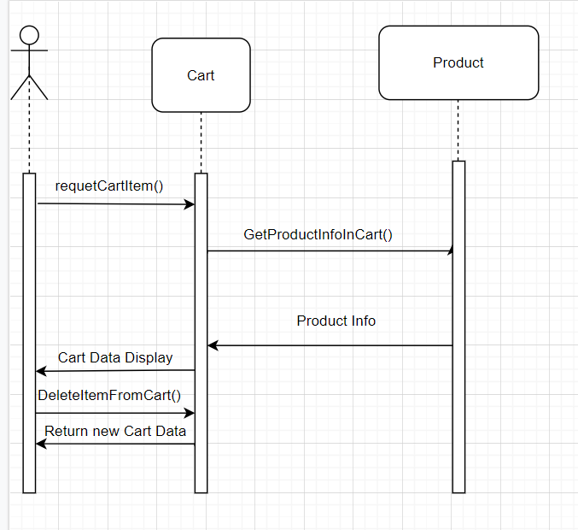

### 

## 13. View List User

### a. Class Diagram

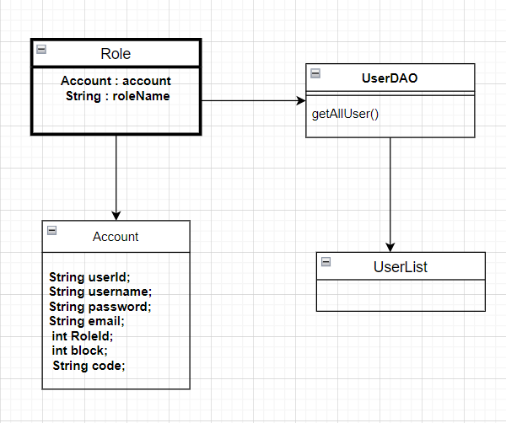

### b. Class Specifications

UserDAO

| No | Method | Description |
| --- | --- | --- |
| 01 | GetAllUser() | Get All User from Database |

### 

### c. Sequence Diagram(s)

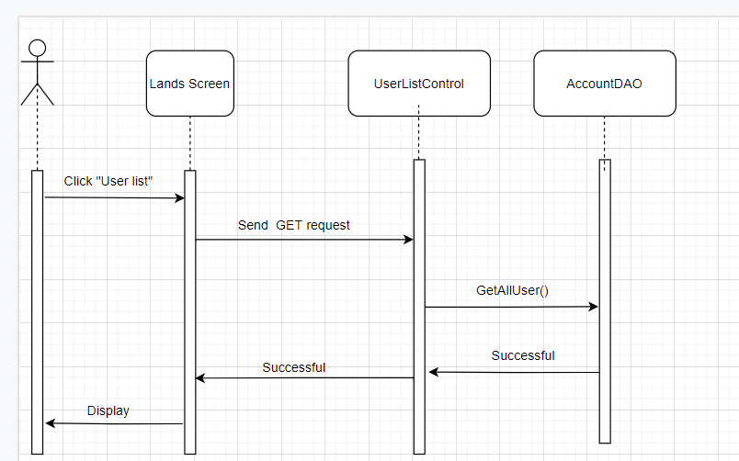

### 

### d. Database queries

select u.*,r.RoleName from Users u inner join role r on u.RoleID = r.RoleID

## 14. Edit Information User

### a. Class Diagram

### b. Class Specifications

UserController

| No | Method | Description |
| --- | --- | --- |
| 01 | processRequest() |  |

BlogDAO

[Provide the detailed description for the class methods]

| No | Method | Description |
| --- | --- | --- |
| 01 | Create User | Insert new user to database |
| 02 | Validate user | Check user if exists |

### 

### c. Sequence Diagram(s)

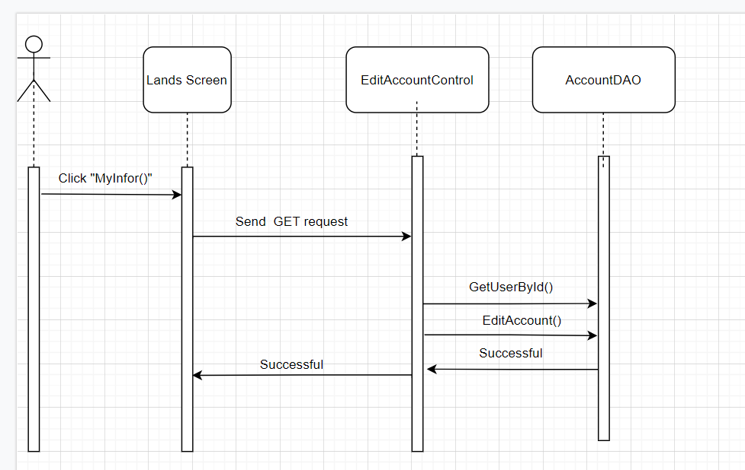

### 

### d. Database queries

Select * from Users

## 15.Set Role User

### a. Class Diagram

### b. Class Specifications

UserController

| No | Method | Description |
| --- | --- | --- |
| 01 | processRequest() |  |

BlogDAO

[Provide the detailed description for the class methods]

| No | Method | Description |
| --- | --- | --- |
| 01 | Create User | Insert new user to database |
| 02 | Validate user | Check user if exists |

### 

### c. Sequence Diagram(s)

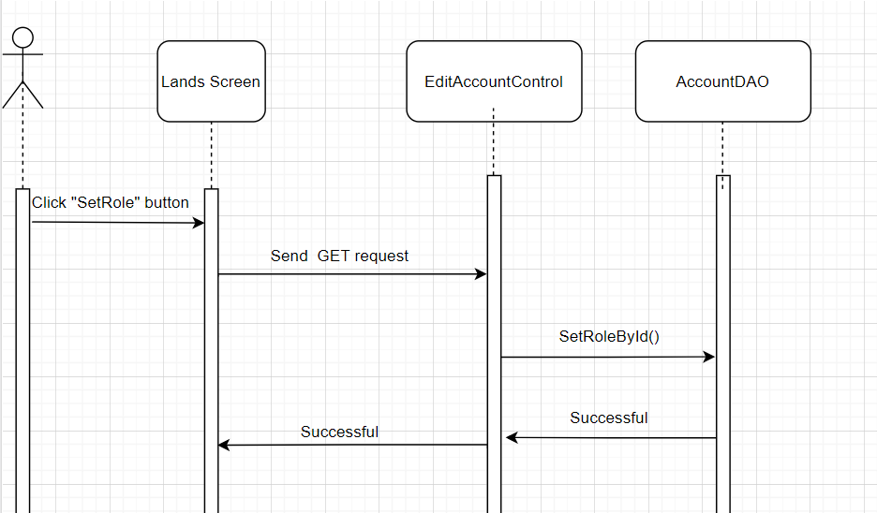

### 

### d. Database queries

Select * from Users

## 16. Block User

### a. Class Diagram

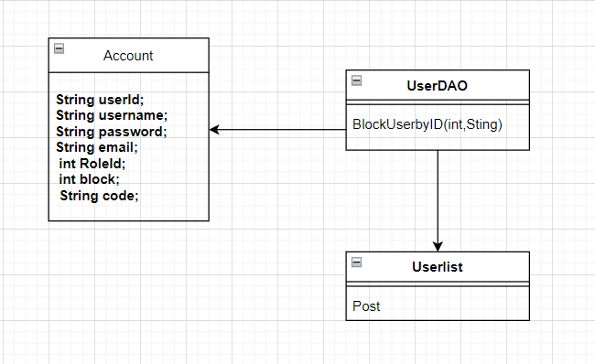

### b. Class Specifications

Userlist

| No | Method | Description |
| --- | --- | --- |
| 01 | Post() | get UserID and change isBlock on Users |

UserDAO

[Provide the detailed description for the class methods]

| No | Method | Description |
| --- | --- | --- |
| 01 | BlockUserbyID | Change isBlock user on database |

### 

### c. Sequence Diagram(s)

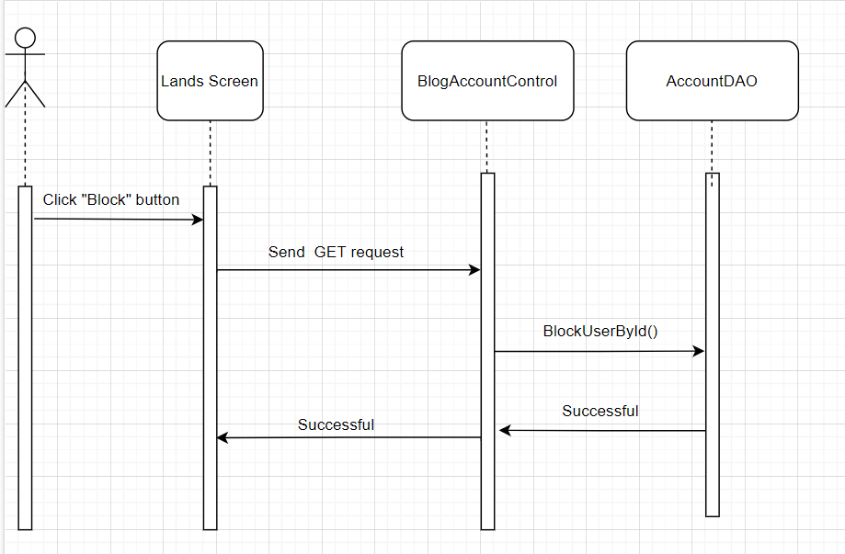

### 

### d. Database queries

Update users

set isBlock = ?

where UserID = ?

## 17. Reset Password

### Class Diagram

### Class Specifications

### 

UserController

| No | Method | Description |
| --- | --- | --- |
| 01 | processRequest() |  |

BlogDAO

[Provide the detailed description for the class methods]

| No | Method | Description |
| --- | --- | --- |
| 01 | Create User | Insert new user to database |
| 02 | Validate user | Check user if exists |

### 

### c. Sequence Diagram(s)

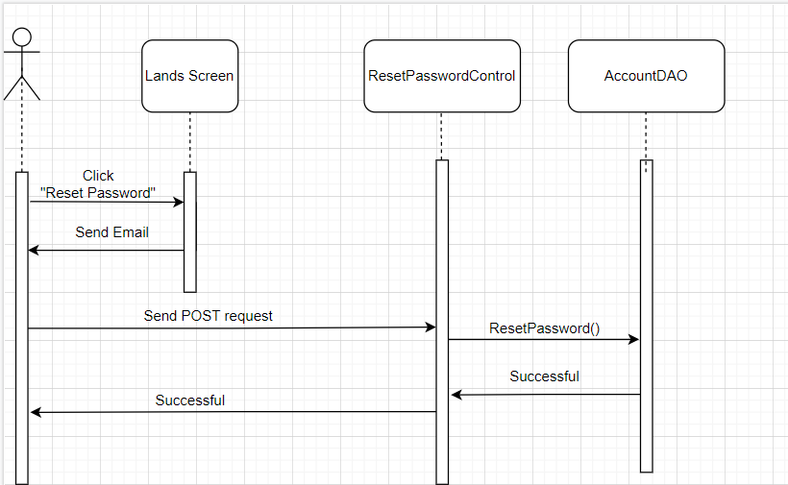

### 

### d. Database queries

Select * from Users

## 18. Change Password

### a. Class Diagram

### b. Class Specifications

UserController

| No | Method | Description |
| --- | --- | --- |
| 01 | processRequest() |  |

| No | Method | Description |
| --- | --- | --- |
| 01 | Create User | Insert new user to database |
| 02 | Validate user | Check user if exists |

### 

### c. Sequence Diagram(s)

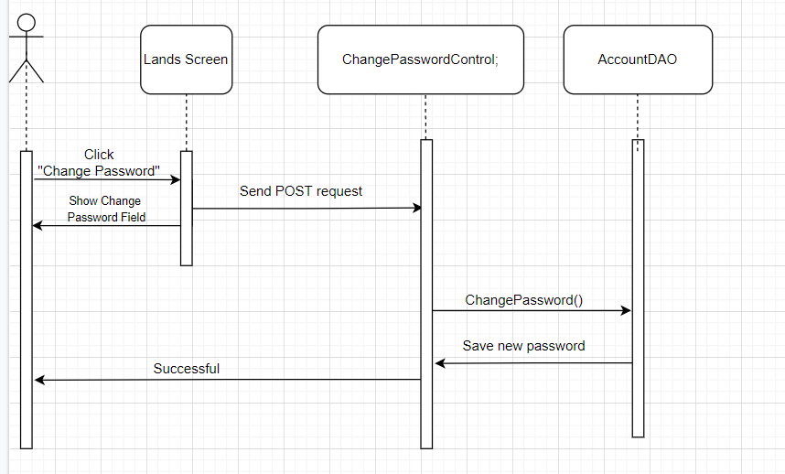

### 

### d. Database queries

## 19. User profile

### a. Class Diagram

### b. Class Specifications

UserController

| No | Method | Description |
| --- | --- | --- |
| 01 | processRequest() |  |

| No | Method | Description |
| --- | --- | --- |
| 01 | Create User | Insert new user to database |
| 02 | Validate user | Check user if exists |

### 

### c. Sequence Diagram(s)

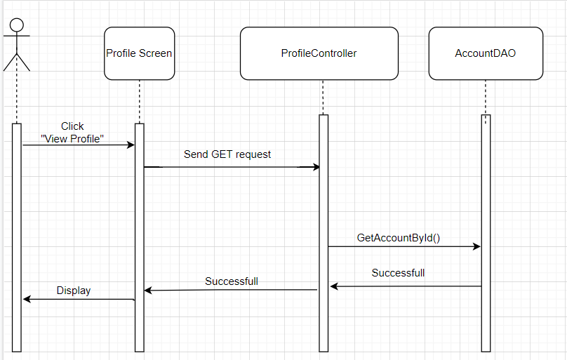

### 

### d. Database queries

Select * from Users

## 20. Order History

### a. Class Diagram

### b. Class Specifications

UserController

| No | Method | Description |
| --- | --- | --- |
| 01 | processRequest() |  |

| No | Method | Description |
| --- | --- | --- |
| 01 | Create User | Insert new user to database |
| 02 | Validate user | Check user if exists |

### 

### c. Sequence Diagram(s)

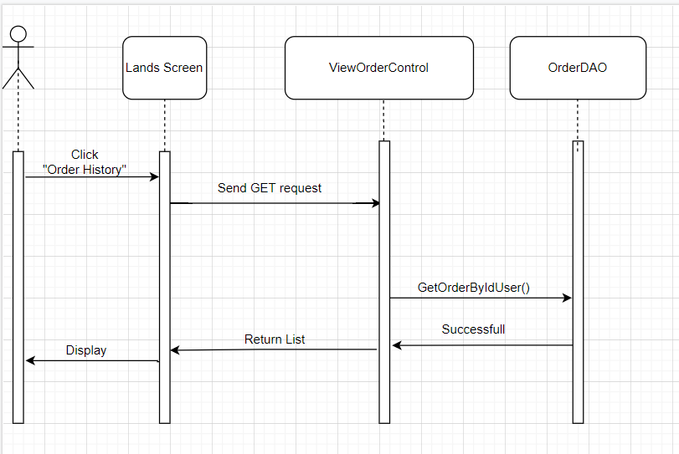

### 

### d. Database queries

Select * from Users

,

## 21. Delete Product

### a. Class Diagram



### b. Class Specifications

ProductDAO

| No | Method | Description |
| --- | --- | --- |
| 01 | deleteProduct() | *DeleteProduct from the database to display on ManageProduct.jsp* |

### 

### c. Sequence Diagram(s)

### 

### d. Database queries

delete from Product where ProductID = ?

## 22. Edit Product

### a. Class Diagram



### b. Class Specifications

ProductDAO

| No | Method | Description |
| --- | --- | --- |
| 01 | editProduct() | *Update from the database to display on ManageProduct.jsp* |

### 

### c. Sequence Diagram(s)

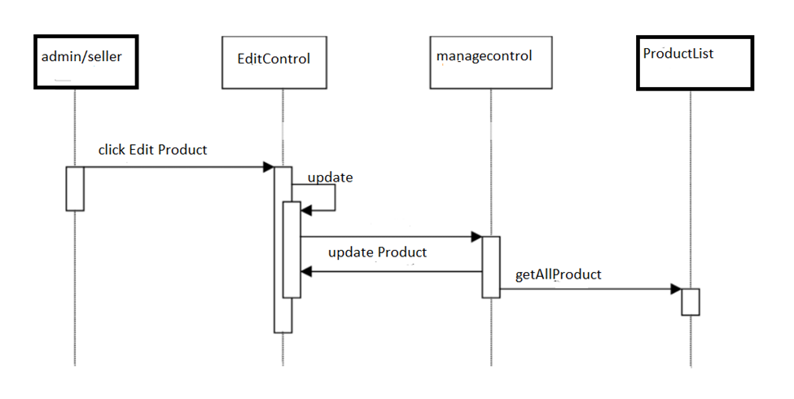

### 

### d. Database queries

UPDATE datatable

SET ... = ?

WHERE …... = ?

## 23. Checkout

### a. Class Diagram

### b. Class Specifications

| No | Method | Description |
| --- | --- | --- |
| 01 | getProductById() | *Get Product which confirm to buy* |
| 02 | saveOrder() | *Insert information in Order table* |
| 03 | SaveOderDetail() | *Insert information in OrderDetail table* |
| 04 | SaveShipping() | *Insert information in Shipping table* |

### 

### c. Sequence Diagram(s)

### 

### d. Database queries

INSERT INTO [dbo].[Orders]

([UserID]

,[TotalPrice]

,[Note]

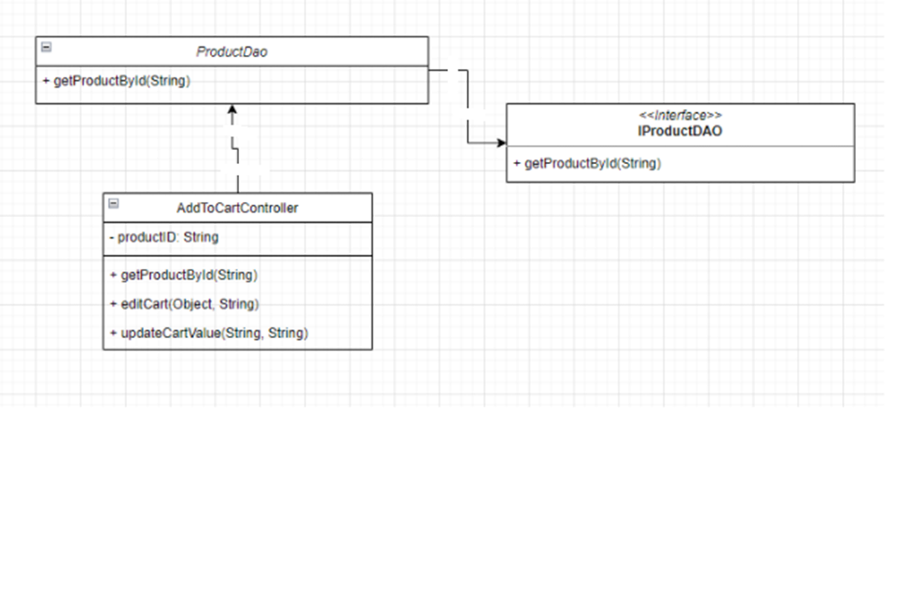 ,[Status]

,[Date]

,[ShippingID])

VALUES

(?,?,?,?,GETDATE(),?)

## 24.Manager Product

1. Class diagram
2. Class specifications
3. Sequence Diagram(s)

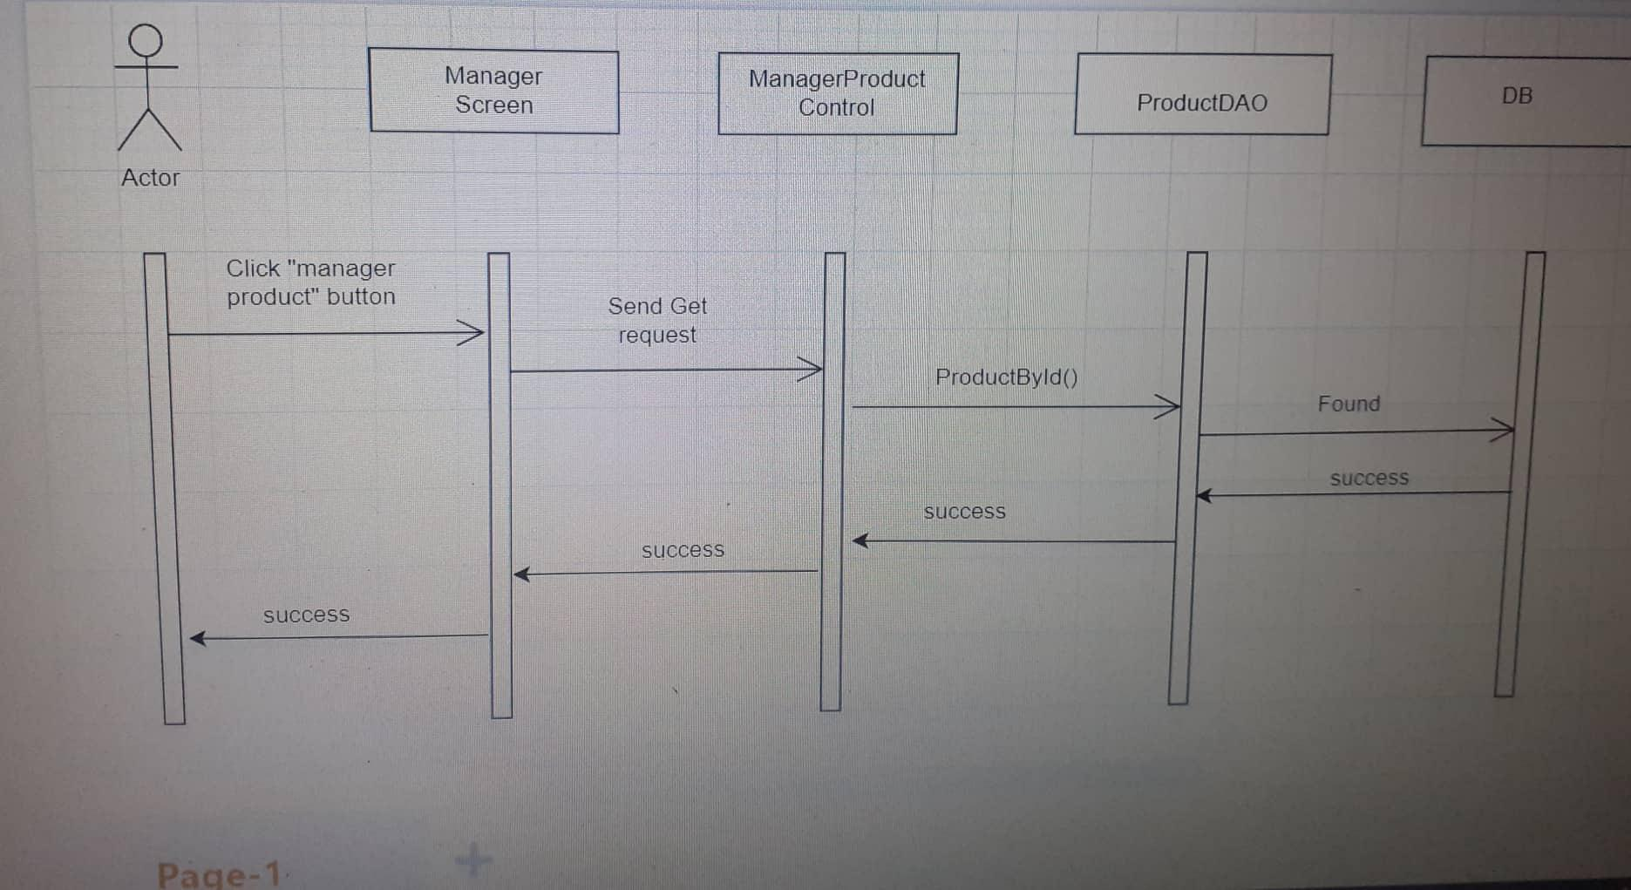

1. Database queries

select p.*,pr.ProductImgURL from Product p join ProductImg pr

+ "on p.ProductID = pr.ProductID

## 25.HomePage

1. Class Diagram
2. Class Specifications

ProductDAO

| No | Method | Description |
| --- | --- | --- |
| 01  02 | getAll  pagingProductBy6 | *Get all product*  *product pagination 6 products 1 page* |

SubCategoryDAO

| No | Method | Description |
| --- | --- | --- |
| 01 | getAllSubCategory | *Get all SubCategory* |

CategoryDAO

| No | Method | Description |
| --- | --- | --- |
| 01 | getAllCategory | *Get all Category* |

BrandDAO

| No | Method | Description |
| --- | --- | --- |
| 01 | getAllBrand | *Get all brand* |

1. Sequence Diagram



1. Database queries

select p.*,pr.ProductImgURL from Product p join ProductImg pr

+ "on p.ProductID = pr.ProductID

# III. Database Design

## 1. Database Schema

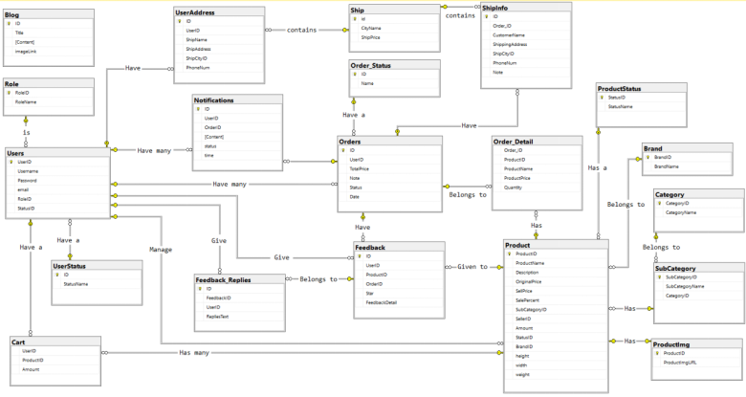

## 2. Table Description

| **No** | **Table** | **Description** |
| --- | --- | --- |
| *01* | *Blog* | *Blog content + image*  *- Primary keys: ID*  *- Foreign keys:* |
| *02* | *Role* | *Role of a user ( Admin,Marketing,Sale,Customer )*  *- Primary keys: RoleID*  *- Foreign keys:* |
| *03* | *UserStatus* | *Account activation status*  *- Primary keys: ID*  *- Foreign keys:* |
| *04* | *Ship* | *Shipping price for each city*  *- Primary keys: id*  *- Foreign keys:* |
| *05* | *Order_Detail* | *Detail of each product in order*  *- Primary keys:*  *- Foreign keys: OrderID, ProductID* |
| *06* | *UserAddress* | *Address for each user*  *- Primary keys:ID*  *- Foreign keys: UserID, ShipCityID* |
| *07* | *Users* | *Users*  *- Primary keys: UserID*  *- Foreign keys: RoleID,StatusID* |
| *08* | *Notification* | *Notification data*  *- Primary keys: ID*  *- Foreign keys: OrderID, UserID* |
| *09* | *ShipInfo* | *Shipping info for each order*  *- Primary keys: ID*  *- Foreign keys: Order_ID, ShipCityID* |
| *10* | *Order* | *Order data*  *- Primary keys: ID*  *- Foreign keys: UserID,Status* |
| *11* | *Feedback* | *Feedback of a product order*  *- Primary keys: ID*  *- Foreign keys: UserID,ProductID, OrderID* |
| *12* | *Feedback_Replies* | *Replies of feedbacks*  *- Primary keys: id*  *- Foreign keys: FeedbackID,UserID* |
| *13* | *Order_Status* | *Status of a order*  *- Primary keys: ID*  *- Foreign keys:* |
| *14* | *Product* | *Product Data*  *- Primary keys: ProductID*  *- Foreign keys: SubCategoryID,SellerID,StatusID,BrandID* |
| *15* | *Category* | *Category Data*  *- Primary keys: CategoryID*  *- Foreign keys:* |
| *16* | *SubCategory* | *Sub Category ID*  *- Primary keys: SubCategoryID*  *- Foreign keys: CategoryID* |
| *17* | *Productimg* | *Image of products*  *- Primary keys:*  *- Foreign keys: ProductID* |
| *18* | *ProductStatus* | *Status of a product*  *- Primary keys: StatusID*  *- Foreign keys: StatusName* |
| *19* | *Brand* | *Brand data*  *- Primary keys: BrandID*  *- Foreign keys:* |
| *20* | *Cart* | *Cart info for each user*  *- Primary keys: UserID*  *- Foreign keys: ProductID* |